Drawing the Line
DIY Toolkit

ABOUT THIS GUIDE
The following guide will instruct you on how to use the Drawing the Line (DTL) tool, facilitate a discussion around safeguarding and inclusion, collect data, and follow-up with actionable steps. This tool is flexible, and can be customized for any type of organization or program setting, however the critical component which must remain is that the game is led by the participants and therefore any external influences should be kept to a minimum.
INTRODUCTION TO DRAWING THE LINE
Addressing safeguarding and barriers to inclusion that young people face in your programs can be both complex and context-dependent. Women Win recognizes that safeguarding issues emerge in the context of historically reinforced systems of power, oppression, and inequality, which are experienced by individuals and groups differently based on their intersectional identities. DTL was developed with the belief that youth participants in sports programming should have the opportunity to be involved in and share their perspective on matters which directly impact them.
DTL is a game that follows a play-based and participatory approach to better understand the level of safeguarding and inclusion in programs through the perspective of the program participants. It is an interactive tool which helps organizations that are interested in improving the conditions of their programs by gathering feedback directly from those involved. The tool is intended for youth participants in your program, but it can also be used by coaches, volunteers, or administrators as a way to gather other viewpoints of the safety and inclusion of programs.
The DTL tool is comprised of a set of approximately 36 statement cards, each of which has a statement and a corresponding drawing (see example below). One at a time, each statement is read aloud and discussed within the group. Participants are asked to share their thoughts and align on how important that particular statement is to them. After the group determines the relative importance of all the statements, they will focus on the “Most Important” statements and determine whether or not they feel their program currently has this or not. The game encourages the participants to have a discussion about the reasons why they think a card is important or not. As a result of this game, you and the participants will have a clear understanding of what safeguarding components the participants feel are a priority, and what they feel is missing in the program.

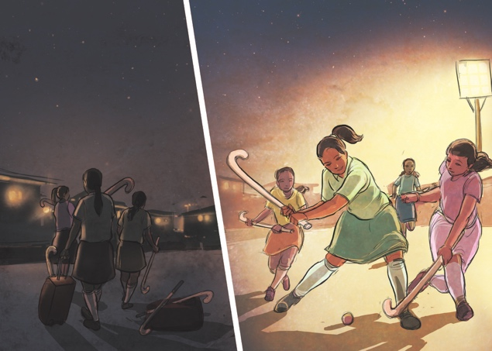

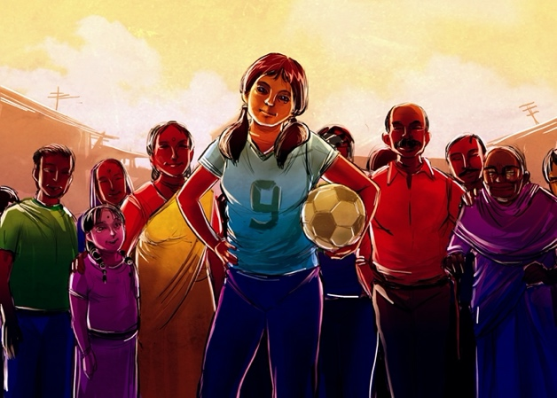
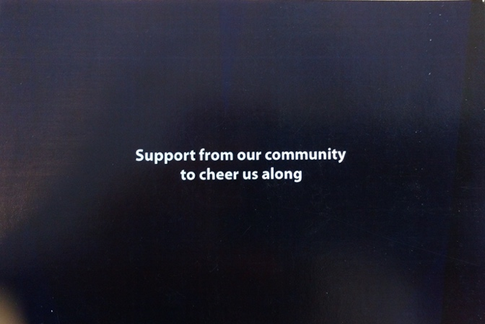
Examples of sample cards with corresponding pictures.

CUSTOMIZE YOUR CARDS
In customizing your own DTL game, you may want to think about what statements are most applicable for your group or program. One way to do this is to ask participants to come up with statements that are important to them along the safeguarding themes of emotional safety, physical safety, inclusion, and rights and equity (or others you/they have identified). You can use these in addition to – or instead of – the sample statements listed in this toolkit. Once the statements are determined, you can have participants draw images that they feel correspond to those statements on the back of the card. A sample template for designing these cards is attached in this toolkit.

SET UP
MATERIALS | Ensure that you have a complete set of the DTL statement cards. This should include:  - 36 statement cards (either from the sample set or created by your group)  - 3 rating cards: Most Important – Important – Less Important  - 2 judgement cards: We have this - We need this  You should also have a notebook to document interesting discussion points and the final cards presented at the end of the game. This will help the organization learn how they can improve their programs to ensure they are safe and inclusive for all.  The total time needed for Drawing the Line is approximately 1.5-2 hours, including energizers, the game and a group discussion. If you have limited time, you may decide to remove one of the energizers or reduce the number of statement cards in the deck. It is possible that some of the statements will not be as relevant for your community or organization, and are therefore not necessary to include in the game. It is important, however, to keep at least 30 cards so that discussion and decision-making is guaranteed. If you are creating your own cards, you may have to budget more time for the game to include time for the participants to develop statements and create images for the cards.
LOCATION | Choose somewhere private where other people will not be watching or listening. It is important to create a safe space for the participants so that they feel comfortable in sharing any thoughts throughout the game.
GROUP SIZE | Group size is very important and groups should be kept to a maximum of 15-20 people per set of cards. This is critical to ensure that all are able to participate in the game and discussion.
FACILITATORS | Ideally, a DTL session is led by two facilitators. A third can be helpful as well, especially when the groups are large.  Facilitator 1: Guide the session, support the group’s participation and maintain the overall flow of the game.  Facilitator 2: Observe the session, noting key conversations, picking up on nuances, body language and examples given.  Optional – Facilitator 3: Monitor the session, ensuring the space is kept safe and private from external observers, while also supporting the guiding facilitator in minimising distractions such as side conversations between participants.  One of the most important roles of a DTL facilitator is to hold a safe space for the participants to freely express their points of view. Listen as much as possible to what is being said, while avoiding leading the discussion towards a certain outcome or influencing answers in any way. Although often challenging, asking open-ended questions to reach deeper insights on a certain issue is key.  Facilitator Tip: Be aware of group dynamics and proactively make sure everyone’s included and participating, not one or two women taking over and making all the decisions themselves.

SESSION
ACTIVITY | FACILITATOR TIPS
- Start the session with a fun energizing game to get the participants moving and excited about the activities to come. | Facilitator Tip: Be sure that all facilitators participate as well! This is a good way to establish the tone for the session ahead.
- After a quick game, have the participants sit in a circle, including the facilitators, either in chairs or on the ground. Introduce the game by explaining the objective and emphasizing that this is a space for them to share what they think without any judgement. The purpose is to learn from them about how they think the programs they’re involved in can become safer and more inclusive for everyone. | Facilitator Tip: Aim to sit at equal level with the participants so that you create a greater sense of comradery and support, rather than standing above or in front of the participants.
- Take a few minutes to explain the materials to the participants. Begin with the statement cards. Explain that each card has two sides: one side with a statement and the other side with a drawing which relates to that statement. Place the 3 rating cards next to each other on the floor so that everyone can see them. State that one by one, you will go through the cards together and decide the level of importance to them. 3 columns will be created with the statement cards being placed under each of the rating cards. | Facilitator Tip: Be sure to pause after explaining the approach and ask if anyone has any questions.
- Have a participant read the first statement card aloud and show the picture to the group. As a group, the participants must decide whether the statement is very important to them as a group, important or not important. They should think about this in the context of the program that they are a part of. Once decided, the participant can place that statement under the corresponding rating card. Encourage participants to read the cards one at a time, so that the entire group is discussing the same card. It also helps if the participants take turns reading the cards, passing the deck from one person to another. | Facilitator Tip: If one of the participants cannot read or is struggling then encourage them to describe what they see in the illustration, if they are comfortable doing so.
- Pass the pile of statement cards to the next participant in the circle and again have them read out the next statement. As a group, decide its level of importance. Continue like this until all cards have been placed in a rating column. As the discussion continues, the cards may be moved between columns if the group decides to change its rating.  Note: There can be no more than 10 cards in the “Most Important” column. This ensures that the participants have a discussion about the reasons why they think a card is very important or not, and then leads to decision-making as a group. A lot of very important information for data collection will come from this part of the discussion, particularly around why something is deemed more important than something else. | Facilitator Tip: If participants are struggling to decide about the 10 “Most Important” cards, you can reiterate that everything is important but if we only have limited resources then what would we focus on.
- Once all statement cards have been placed in a column, you may move onto the next phase. You will only use the cards that have been placed in the “Most Important” column. The cards under “Important” and “Less Important” can be moved to the side.
Note: It is interesting to note which statements are in the “Less Important” pile as we might learn that things which administrators and coaches find important are not in fact as important to the youth participants as other topics.
- Now that the participants have identified the elements that they consider to be most important for a safe and inclusive program, it is time to define what they already have within their program and what they don’t have but clearly feel they need.
- If there is time, have another quick energizer to get the participants ready for the next part. | Facilitator Tip: Make sure you manage your time very well, if it is limited you may decide to remove the energizer or try to speed up the card placement process somewhat.
- Place the two judgement cards in the middle of the circle. As was done in the previous round, read the “Most Important” statement cards one by one and as a group decide whether this is something they already have in their program/organization or do not have but need. Each card should be placed under one of the following cards: “We have this” or “We need this”.

DISCUSSION AND FOLLOW UP
To complete the game, it is important to hold a deeper discussion about how the participants can play a role in incorporating some of the missing components of safeguarding and inclusion into their programs. Either as a large group or in smaller groups, use the “We need this” cards and ask the participants to think about how they can be proactive to get the things they need, how the group could work together to make these changes, and what other solutions can be introduced or explored. Write down some of these points and share with your team after the game.
Once this is complete you will have a clear understanding of what the participants feel is missing in the program and is important to include. Following the game, you may want to share the learnings with the rest of your team.
The sample cards are categorized into themes: emotional safety, physical safety, inclusion, and rights and equity. If your group makes their own cards, think about if they fit into one of these themes or represent another safeguarding theme. After the game, noting which themes were most present in each of the columns can help you talk with your team about the safeguarding themes that you have under control and those which could be improved.
Drawing the Line Sample Card Examples
Theme | Card Title | #
Emotional Safety | Someone with authority whom you can talk to when you have a problem | 1
 | Our families encourage and support us | 2
 | Support from our community to cheer us on | 3
 | Support from our coaches | 4
 | Support from teammates | 5
 | We should feel comfortable with our coaches | 6
 | Coaches do not raise their voices for disciplinary reasons | 7
 | We have local role models to inspire us | 8
 | We should be able to point out behavior that’s not okay | 9
 | We should have a space to play without fear of harassment | 10
Physical Safety | Playgrounds/courts/field within easy walking distance from our home/school | 11
 | Separate changing rooms for girls and boys | 12
 | Well-lit play areas so you can also play after dark | 13
 | Easy access to a First-Aid box | 14
 | Clean toilets for girls and boys | 15
 | Drinking water is easily accessible | 16
 | Strength to stand up against bullying and abuse | 17
 | Proper shoes/gear to play safely | 18
 | Coaches do not resort to physical abuse for disciplinary reasons | 19
Inclusion | No one should be left out of a sport due to their disability | 20
 | No one should be left out of sports because of their gender | 21
 | No one should be left out of sports because of financial status | 22
 | No one should be excluded from sports due to a lack of skill | 23
 | No one should be left out of sports due to their race or ethnicity | 24
 | No one should be left out of a sport due to their religion | 25
 | No favoritism, fair application of rules for all | 26
 | We should be allowed to play in culturally acceptable attire | 27
 | We should all be involved in deciding the rules of play | 28
 | Clearly marked place to play that’s big enough for everyone | 29
Rights and Equity | Able to balance playing sports with studying and household chores/duties | 30
 | Girls can be leaders too | 31
 | We should have women coaches | 32
 | We have basic equipment to play, including sports gear and uniforms | 33
 | If we break the rules, we get disciplined in a fair way | 34
 | Private place to dispose of sanitary napkins or other sanitary products | 35
 | Time to train and compete | 36
 | Our rights and responsibilities with regard to sport are clearly visible | 37
 | Boys understand why playing sports is good for girls | 38
 | Referee to fairly enforce the rules | 39

Rating & Judgement Cards (Print and cut out the cards below to use in the game.)
MOST IMPORTANT

IMPORTANT

LESS IMPORTANT

WE HAVE THIS

WE NEED THIS

Statement Card Template
Use the template below to create your own cards. You can type your safeguarding priorities in the boxes, print, and then cut them out leaving the space on the back blank for drawing an image. You can also print blank cards and leave space for the participants to write their own priorities during the game.

